http://www.brecorder.com/general-news/172/1235415/

September 28, 2013

Speakers call for allowing media access to PA panels

Recorder Report
Participants of a workshop held here under the auspices of Development, Environment, Legal Aid and Technical Support and Advocacy Association (DELTA) called for the access of media representatives to the proceedings of all panels of the Khyber-Pakhtunkhwa Assembly Public Accounts Committee (PAC) to guarantee the right to information of the people.
Under contract with the United States Agency for International Development (USAID), the Development, Environment, Legal Aid, Technical Support and Advocacy Association (DELTA), a non-governmental organization, is implementing a project titled 'Strengthening Citizens' Voice through Advocacy (SVCA)' in the districts of Swabi, Mardan, Peshawar, Nowshera and Charsadda.
The participants of the workshop included clerics, civil society and media representatives. The participants reviewed the Right to Information (RTO) Ordinance, promulgated by the PTI government in Khyber-Pakhtunkhwa clause by clause and make recommendations for bringing further improvement in it. They also called for the extension of the law to Federally Administered Tribal Area and inclusion of a journalist on the proposed commission to be constituted under it.
They said that the Ordinance is already presented in the provincial assembly in the shape of a bill and the Speaker referred it to a special panel of the House comprising of the members of all parliamentary groups in the Assembly. The Citizens' Voice Project, that is helping DELTA to implement its SVCA project, aims to improve engagement between citizens and government in order to promote good governance in Pakistan, by strengthening citizens' voice and public accountability.
DELTA conducted a meeting with its Media Forum in collaboration with the National Research and Development Foundation (NRDF) here Thursday. The project was introduced by Naazlee Sardar, President of DELTA and Yousaf Riaz Khalil, Senior Board of Governor for DELTA.
They said that DELTA is in the process of conducting various activities to eradicate corruption from the society and in this aspect have arranged different awareness and advocacy programmes such as district level conferences, citizens' group meetings, radio programmes, consultation/workshops and other interactive sessions with stakeholders of the society.
The participants are of the view that RTIO KP 2013 promotes transparency, which directly leads to lesser secrecy and better governance. However, it is very important for the legislators to enact the RTIO KP 2013 in its current form and not make too many radical changes to the 32 clauses of the ordinance, and follow it up with a comprehensive set of rules for effective implementation.
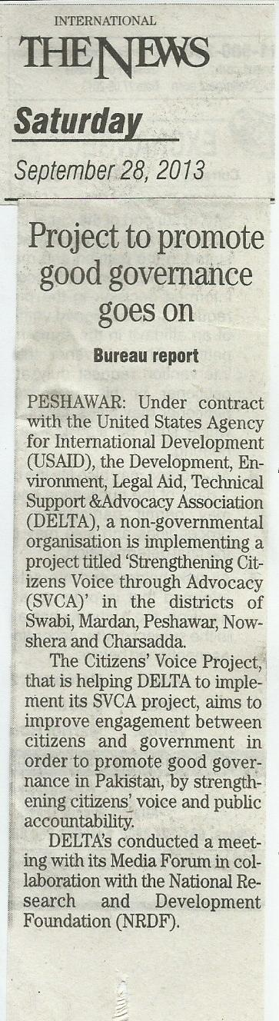
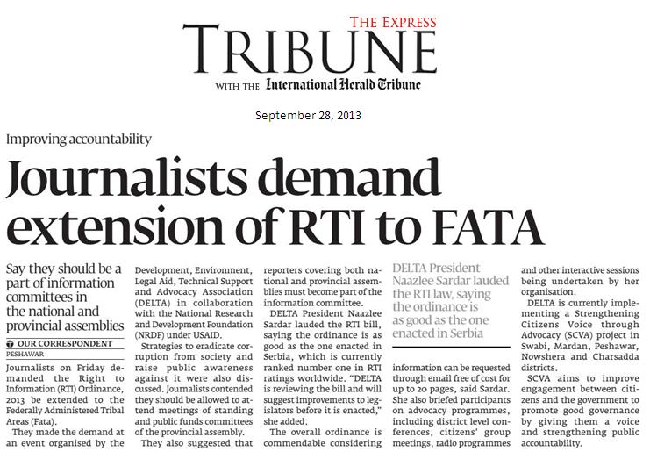

http://statesman.com.pk/index.php?edition=peshawar&date=2013-09-27&page=2&type=newspaper
